CDT Thesis Twitter Conference Entries 06.11.2023
Some entries contain gifs & videos; to view them, see #cdttwecon or visit @CDTFluidsLeeds

Lucy Godson, AI Medical Diagnostics and Care, @godson_lucy
1. Immunotherapy has transformed the treatment of melanoma patients. Yet we still don't understand why around 50% of patients don't respond to treatment. In my PhD project "Predicting melanoma patient outcomes using digital pathology" I use tumour images to explore why #CDTTweCon
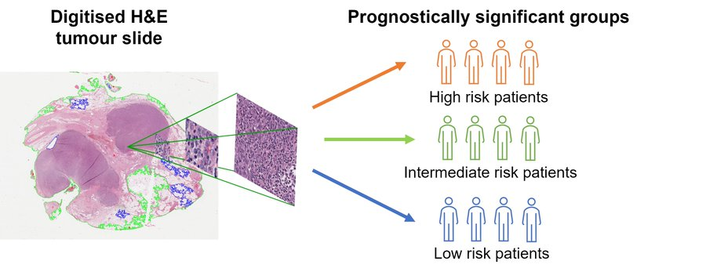
2. The problem with these digitised images is that they are huge! If you printed one out pixel by pixel, it would be the size of a tennis court. This is a big problem computationally, as even a powerful computer will struggle to analyse billions of pixels all at once #CDTTweCon
3. To solve this, I break the larger images up into smaller patches, which are processed individually or by connecting the patches together in a graph. Then we classify patients based on their outcomes, using AI, to see which tumour cells contribute to better survival #CDTTweCon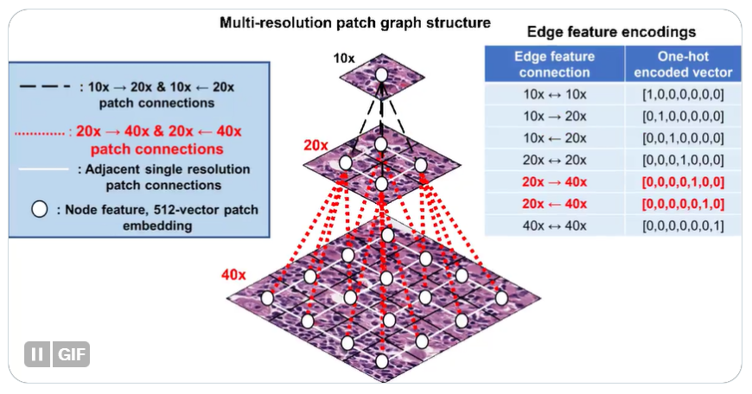

Janine Preston, Molecules to Product, @JaninePreston8
1. Ever wondered how to stabilise foams (e.g. whipped cream/ice creams) and emulsions (e.g. skin creams) without surfactants. My thesis is on ‘The behaviour of xanthones as Pickering foam and emulsion stabilisers’. Read on to find out more. #CDTTweCon
2. In Pickering stabilisation, the interface/boundary between oil and water droplets or water and air bubbles is stabilised by solid particles (xanthone crystals). Crystals cover the surface and stop smaller bubbles/droplets joining to form larger bubbles/droplets. #CDTTweCon
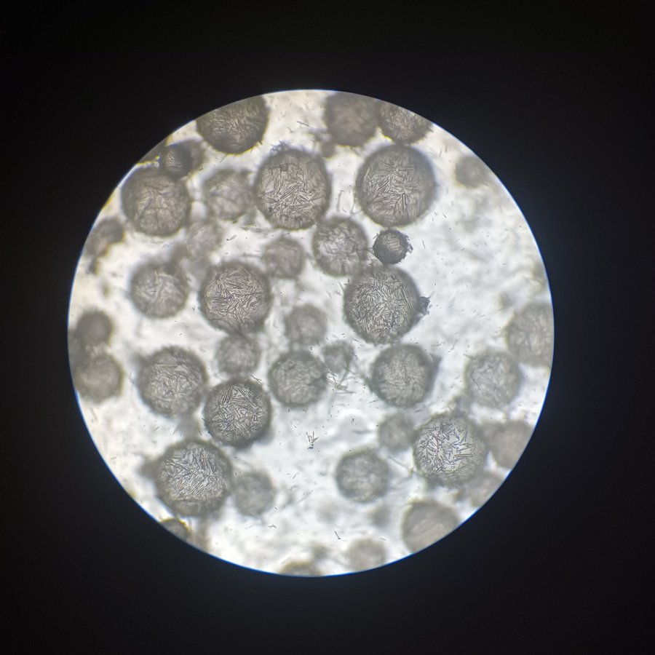
3. Crystal size, loading and aspect ratio (width: height ratio) affect the size and longevity of the emulsion droplets/foam bubbles. Stability data demonstrated the droplet/bubble lifespan: <3 months (low aspect ratio), >9 months (higher aspect ratio). #CDTTweCon

Rose Collet, Fluid Dynamics, @rm_collet
1. Can maths predict tumour growth? I look at patient-specific breast tumour models to predict the outcome of chemotherapy. Many patients receive chemo, but it doesn't always work. Predicting this early on would allow for alternative treatments to be explored. #CDTTweCon
2. Our models are patient-specific, due to how variable treatment response is. This means several parameters are measured directly from MRI data, and others are calibrated as shown here. #CDTTweCon
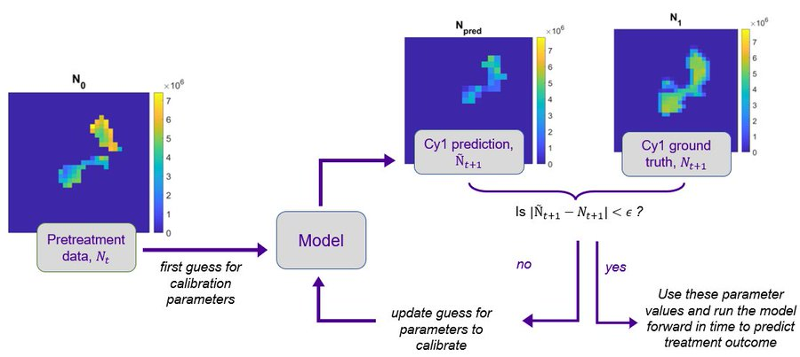
3. We can then run the model forward in time to predict treatment response! #CDTTweCon
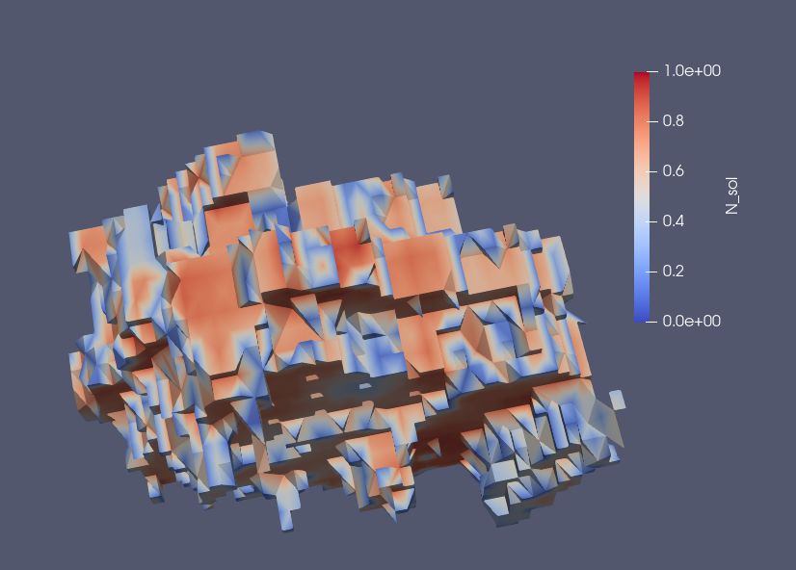

Jacob Perez, Fluid Dynamics, @FluidsJacob
1. The Jet stream is a band of winds coming the west, that has large impacts on our surface weather. My research involves developing new methods to characterise the jet position, strength and tilt and how these features alter the location of extreme weather. #CDTTweCon
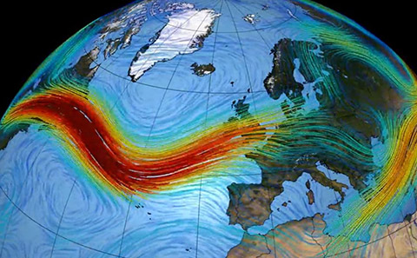
2. In my work we have developed a new way to characterise the Jet, by extracting what we call Jet objects from the wind data. The Jet position (blue dot), tilt and strength are all calculated by using the winds within Jet object. #CDTTweCon
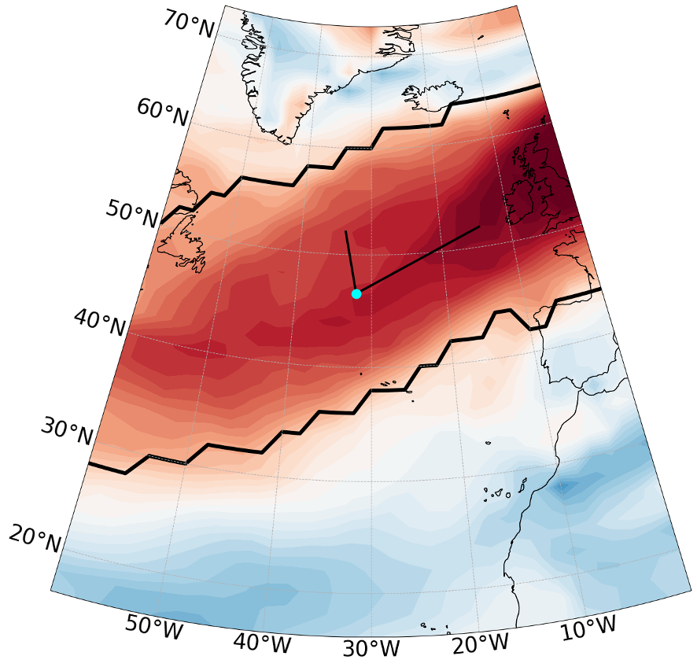
3. By considering different Jet characteristics, leads to different surface impacts! Below is a plot of the rainfall (blue-wetter, brown -drier) where the tilt is increasing from left to right. Changes in the tilt lead to different wet and dry areas in Europe. #CDTTweCon
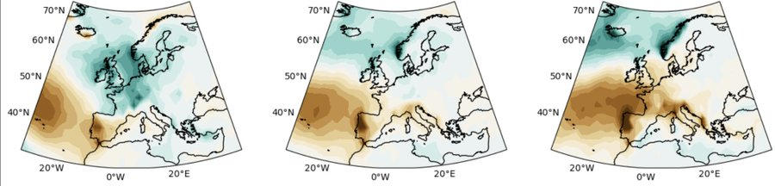

Jo Kershaw, Fluid Dynamics, @Jo_in_the_flow
1. Rotating convection of liquid metals in the Earth's outer core: this flow produces our magnetic field, protecting us from the solar wind. The presence and nature of such fields could illuminate the structure of rocky planets, gas giants, their moons and exoplanets. #CDTTweCon
2. The flows producing and maintaining these fields are poorly understood. Spherical shell simulations are examined with the goal of discovering the conditions on the tangent cylinder boundaries. This should enable us to model a region of the flow with more precision. #CDTTweCon
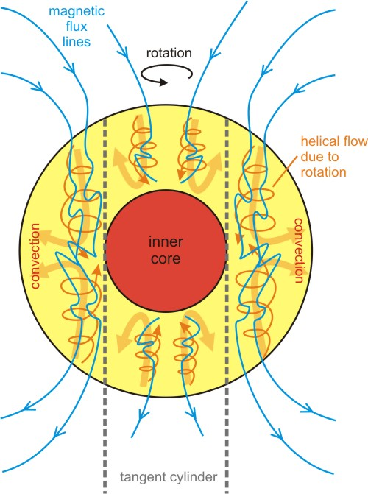
3. The temperature and velocity conditions at the 'walls' of the tangent cylinder are imposed on cylindrical models in Nek5000. We hope to show consistency with experimental and numerical results. Next: a comparison between polar, equatorial and mid-latitude flow. #CDTTweCon

Alex Edwards, Fluid Dynamics, @A_Edwards7
1. Assessing the effects of weather conditions on airborne transmission risk in naturally ventilated hospitals: Airborne transmission plays an important role in the spread of many diseases, but how is it affected by weather? Many UK hospitals are naturally ventilated. #CDTTweCon
2. Weather conditions such as wind speed, wind direction, pressure and temperature can affect natural ventilation, leading to ventilation rates far below the recommended standard, or causing irregularities in the airflow to neighbouring indoor spaces, increasing risk. #CDTTweCon
3. We show that weather conditions alone can lead to unexpected spikes in the concentration of infectious material when using natural ventilation, increasing the risk of infection on particular days or weeks. Which day would you prefer to visit the hospital ward? #CDTTweCon
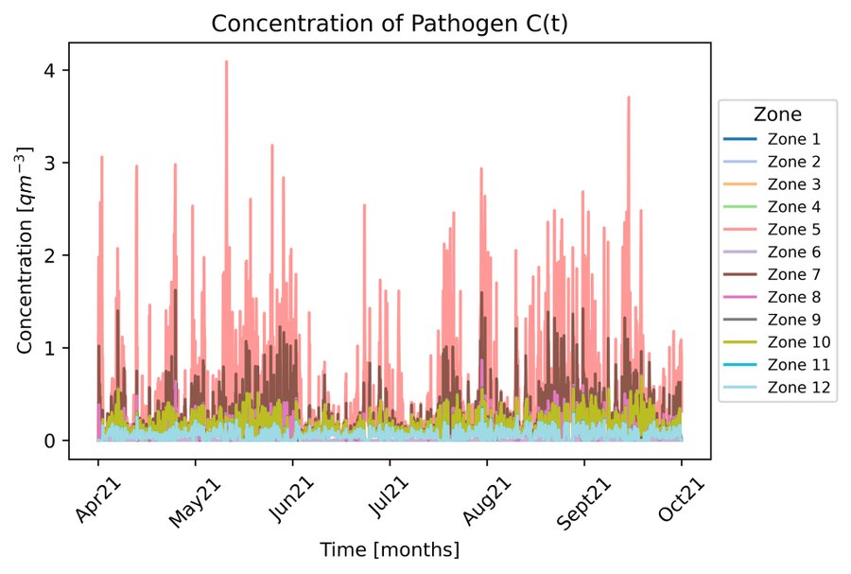

Jose Florido, Fluid Dynamics, @JoseFlorido99
1. On Adaptive Sampling of Collocation Points in PINNs: Interest in AI has sky-rocketed recently, especially for researchers wanting to adapt it for scientific problems! One such adaptation named PINNs harnesses our knowledge of physics to solve a variety of problems. #CDTTweCon
2. In traditional computer modelling, scientists developed ways of focusing on areas of interest like shockwaves to improve accuracy. PINNs learn the physics at points, and so the idea was to parallel the approach by smartly placing the points in interesting areas! #CDTTweCon
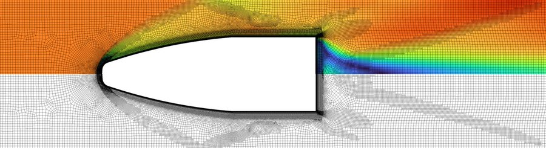
3. So far, I’ve investigated how using different types of information distributes points, and which distributions are most effective at increasing the accuracy of our solution. However, there is still a lot to understand about how point distribution guides learning! #CDTTweCon
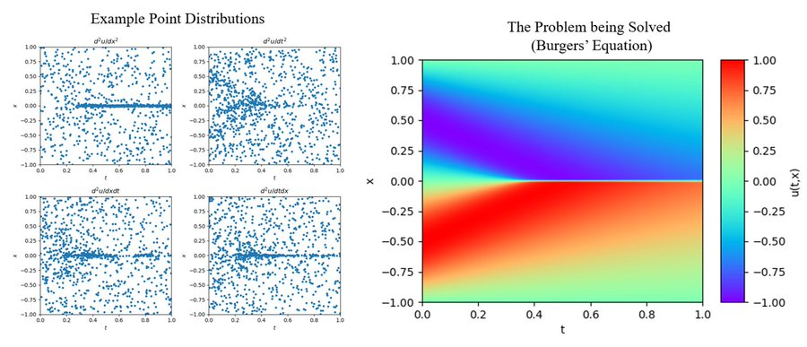

Hannah Robinson, Water-WISER, @_hannah_jayne
1. Beyond The Binary: Designing a Gender Inclusive Sanitation Future Where’s the menstrual bin? Tens (if not hundreds) of documents exist that describe gender inclusive spaces, yet they’re rarely used. This interdisciplinary qualitative research documents why. #CDTTweCon
2. The research begins at a Global level assessing inclusion practises of the World Bank and UNICEF, then explores the National implementation of India’s Swachh Bharat Mission (Sanitation program), followed by a community case study of LGBTQ+ sanitation experiences. #CDTTweCon
3. Submitting early 2024, the thesis includes a Published Journal Article for Development Policy Review, and 8 chapters exploring gender inclusion in sanitation at Global, National and Community Levels, informed by 5 months of fieldwork with 131 participants. #CDTTweCon

Yatin Darbar, Fluid Dynamics, @DarbarYatin
1. Mixing Dynamics between Inkjet-Printed Droplets: Inkjet technologies concern depositing droplets on a surface. In some cases these droplets mix in order to create a new material. But how exactly do these impacting droplets mix without any outside influence? #CDTTweCon
2. https://drive.google.com/file/d/1Z9jAKVBw3TOekeRfYz1aopM28Kppk8tI/view
Using @openfoam we can see how the impact of spreads the drops out to initially mix the drops together, after we can speed up time to see when the combined droplet comes to a rest diffusion takes over and mixes the remainder of the drops #CDTTweCon
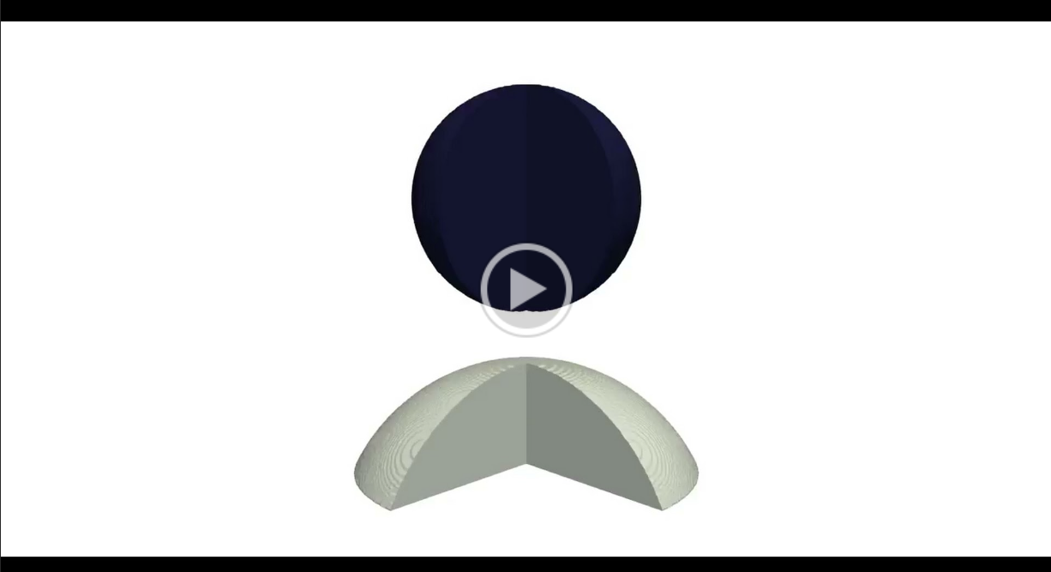
3. One interesting result we have found is that for applications that require side by side printing (see pictures in figure) the droplets will take 10x as long to mix! #CDTTweCon
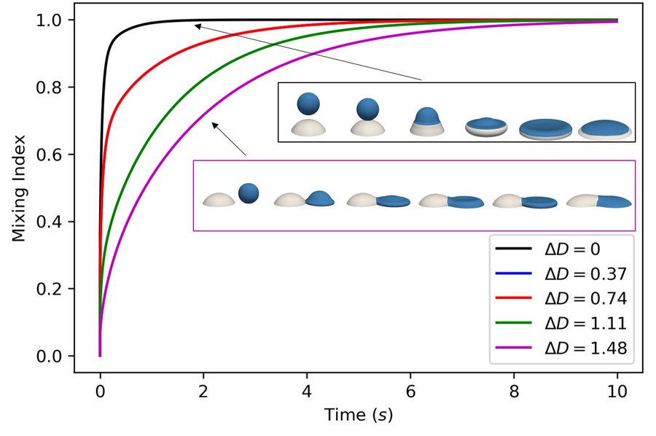

Julie Frank, Fluid Dynamics, @jyfrank4
1. How we can use Phase Change Materials (PCM) to manage the growing heat load problem in transient heat load management systems for future aircraft – a thread on my PhD project on developing novel PCM heat exchanger designs. #CDTTweCon
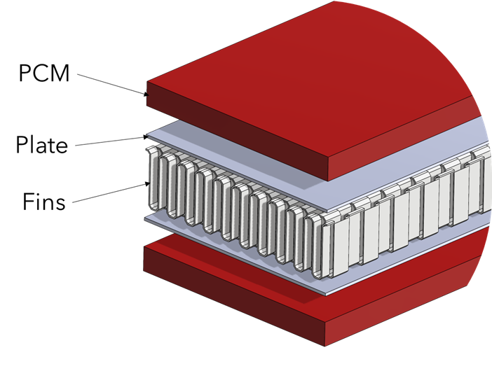
2. PCM are materials that can absorb and release a large amount of heat at constant temperature during phase change. They could be used within the thermal management system to absorb peak heat loads in aircraft, leading to a smaller main heat exchanger. #CDTTweCon
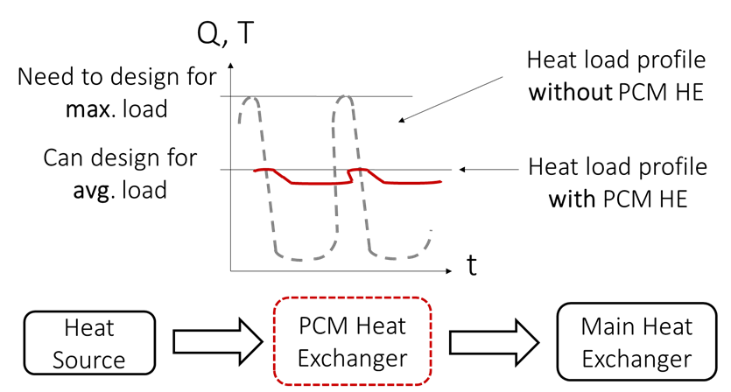
3. We’ve developed a model based on the ε-NTU method to predict the thermal performance of simple PCM-compact heat exchanger. This gives similar results to CFD simulations at a fraction of the computational cost, making it an ideal tool for the early design stage. #CDTTweCon
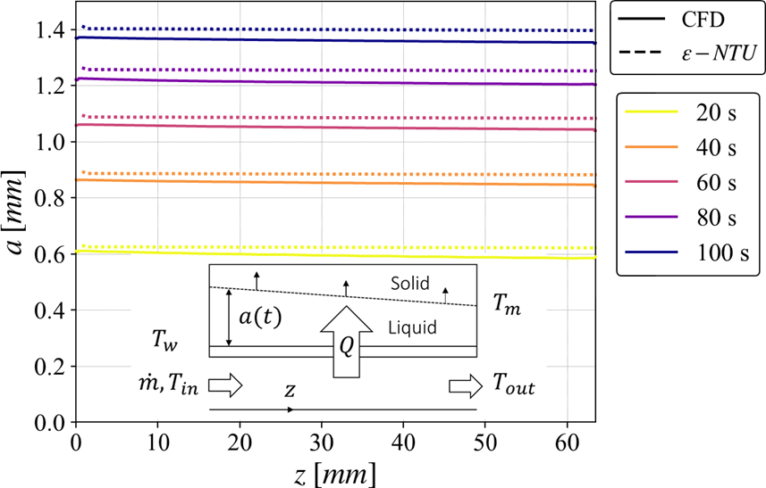

Ciara Higham, Fluid Dynamics, @CiaraHigham
1. Experimental methods to investigate environmental contamination from a toilet flush in a mechanically ventilated chamber #CDTTweCon
Toilets have potential to spread diseases by releasing droplets/aerosols (that may carry harmful pathogens) into the environment when flushed
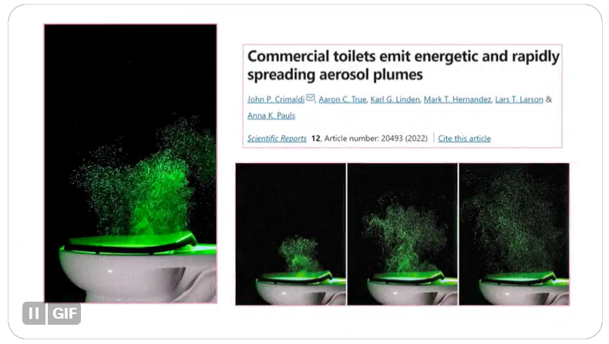
2. While larger droplets tend to land on surfaces, smaller ones can remain in the air for extended periods before ventilation removes them. It's possible for a person to become sick if they inhale these pathogens or touch contaminated surfaces & then their face #CDTTweCon
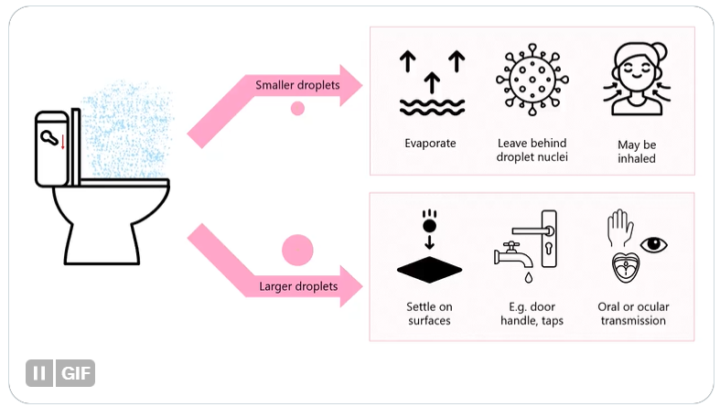
3. I’m conducting experiments to investigate the toilet plume under varying ventilation conditions. I'm using E. coli in the toilet bowl to quantify viable bacteria that becomes aerosolised.
(GIF for some results)
How might this feed into a mathematical risk model? #CDTTweCon
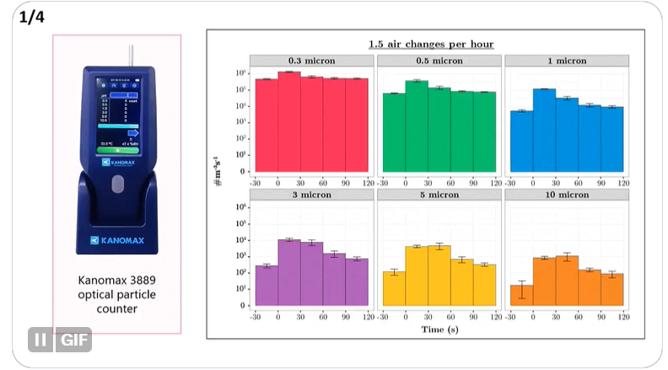

Kasia Nowakowska, Fluid Dynamics, @KasiaCDTFluids
1. Ever wondered how meteorologists predict sudden storms? Short-term precipitation forecasting is vital for fast-changing, intense weather. Current methods track storms well but struggle with predicting new cell formation. #CDTTweCon
2. My research asks; can we use a simplified model to better understand how storms initiate & learn more about the short-term prediction of storms? I use Dedalus to run simulations of a moist Rayleigh-Benard model (Rainy-Benard), producing cells which initiate and decay #CDTTweCon
3. So far, I've worked on understanding what drives initiation, focusing on gravity waves and energy in the system (CAPE, CIN &KE). The next step? Using machine learning! Utilising reservoir computing to forward propagate features and predict cell initiation & movement #CDTTweCon

Zoe Hancox, AI Medical Diagnostics and Care, @ZLHancox
1. Temporal Graph-based Convolutional Neural Networks (CNNs) for Electronic Health Record (EHR) Predictions. Using 3D EHRs, can we foresee hip and knee replacements? Uncover unique health trajectories leading to joint replacements? #CDTTweCon
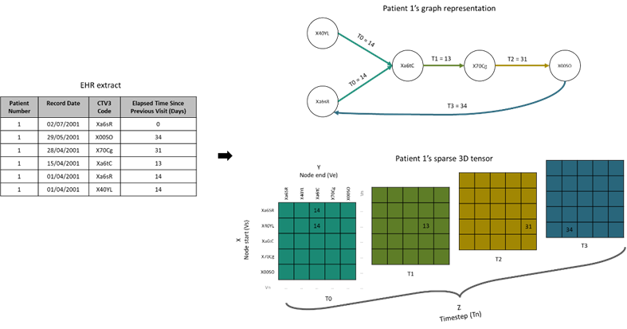
2. People are living longer, and joints becoming more worn. Predicting the need for hip and knee replacements in advance with 3D CNNs using Read codes and GP visit intervals could enhance treatment timing and preventive care, improving health outcomes. #CDTTweCon
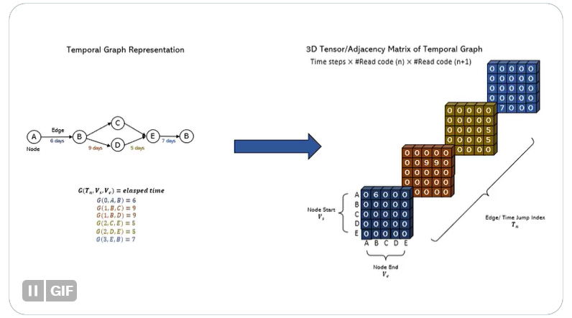
3. We can put 3D constructs of individuals EHRs into AI models that learn patterns within the data to make predictions, finding which patients will be likely to need a joint replacement for intervention targeting. #CDTTweCon
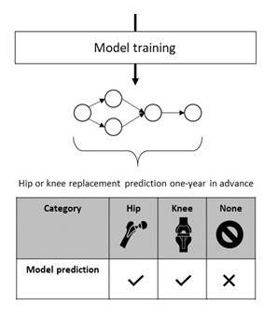

Anna-Grace Linton, AI Medical Diagnostics and Care, @Linton_AG
1. PhD Title: The Role of AI in Unlocking Health Insights from #PROMs Free Text Comments
Patient-reported outcome measures (PROMs) are surveys that are key in revealing what really impacts patient health and outcomes. #NLProc #AI #PatientInsights #CDTTweCon
2. Patients share so much that cannot be captured by rating scales alone. That's where free text comments come in! Patients can share here unrestricted. But, with thousands of comments to sift through, these valuable insights often get ignored. #PatientVoice #CDTTweCon
3. My PhD has looked at ways Natural Language Processing (AI for text) can be used to pick out what is discussed in the comments. I've tested its usefulness and the added value. I share my approach with both patients and researchers to further improve my analysis. #CDTTweCon

Emily Butler, Fluid Dynamics, @EJ_Butler_
1. An investigation of the fluid structure interaction in articular cartilage across disparate scales. Cartilage tissue is found at opposing bone surfaces in joints. Can mathematical modelling of cartilage across length scales help fix that niggling pain in your knee? #CDTTWeCon
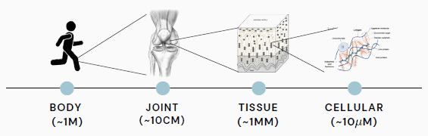
2. Healthy cartilage tissue facilitates smooth motion of the knee but can cause pain when it becomes damaged. To understand this degeneration, we need to capture complexities at the cellular scale and map these to the tissue scale mechanical response. #CDTTWeCon
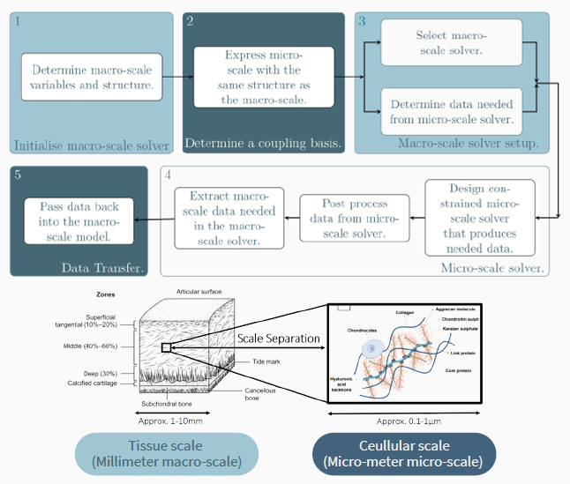
3. An accurate computational model of the tissue structure and response under damage is essential to inform rapid pre-screening of therapeutic interventions. Helping you avoid that knee replacement and keep running pain-free well into your retirement years! #CDTWeCon
